**Project Agenda:**

To perform API testing using the tool Postman for the application Open Weather

To perform API Testing using REST Assured

To perform load testing using JMeter

Detailed Scenario 1:-Jmeter Project

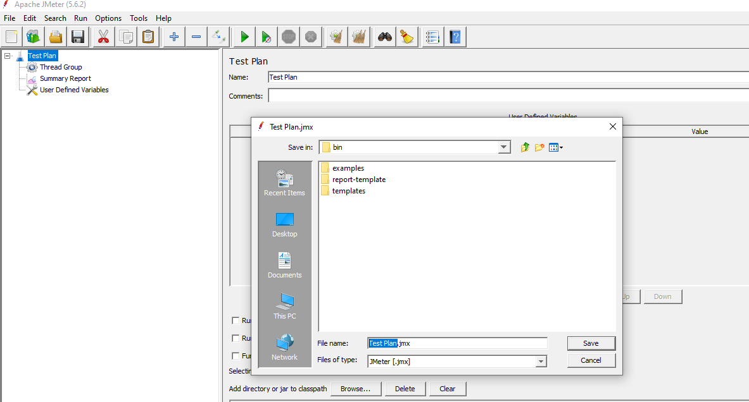

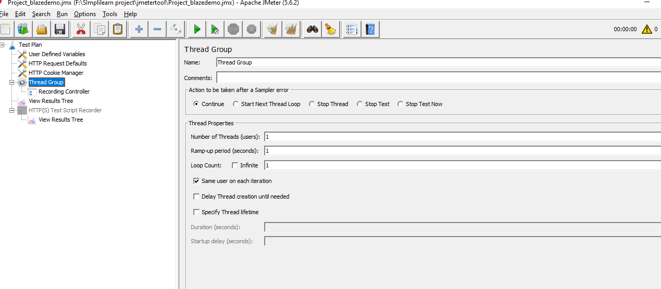

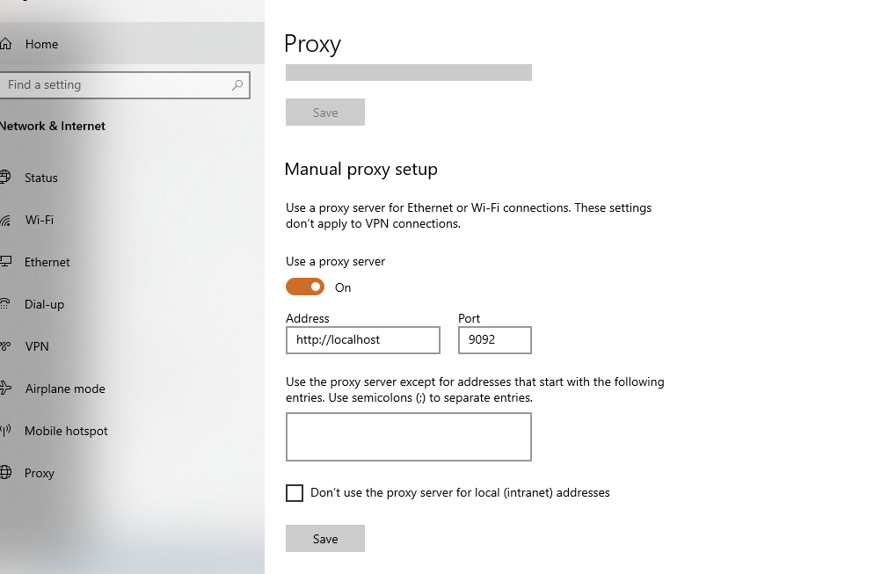

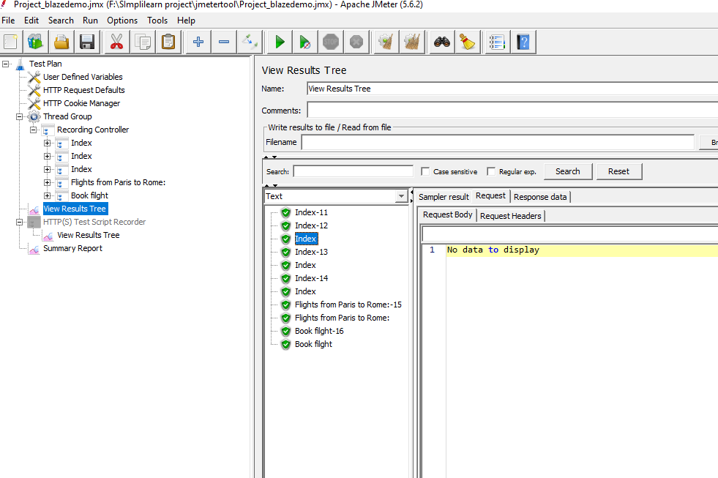

Final Summary report:-

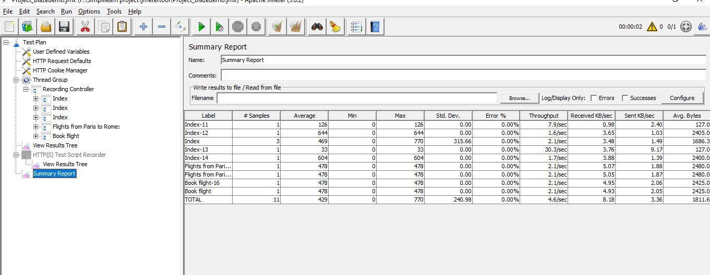

**Detailed Scenario 2 using REST Assured:**

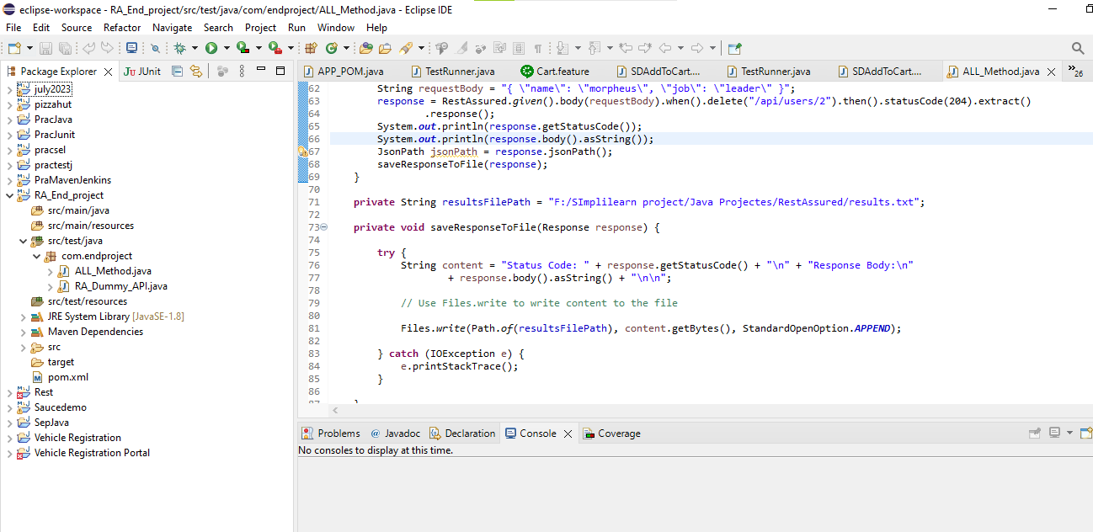

**All Case-Passed**

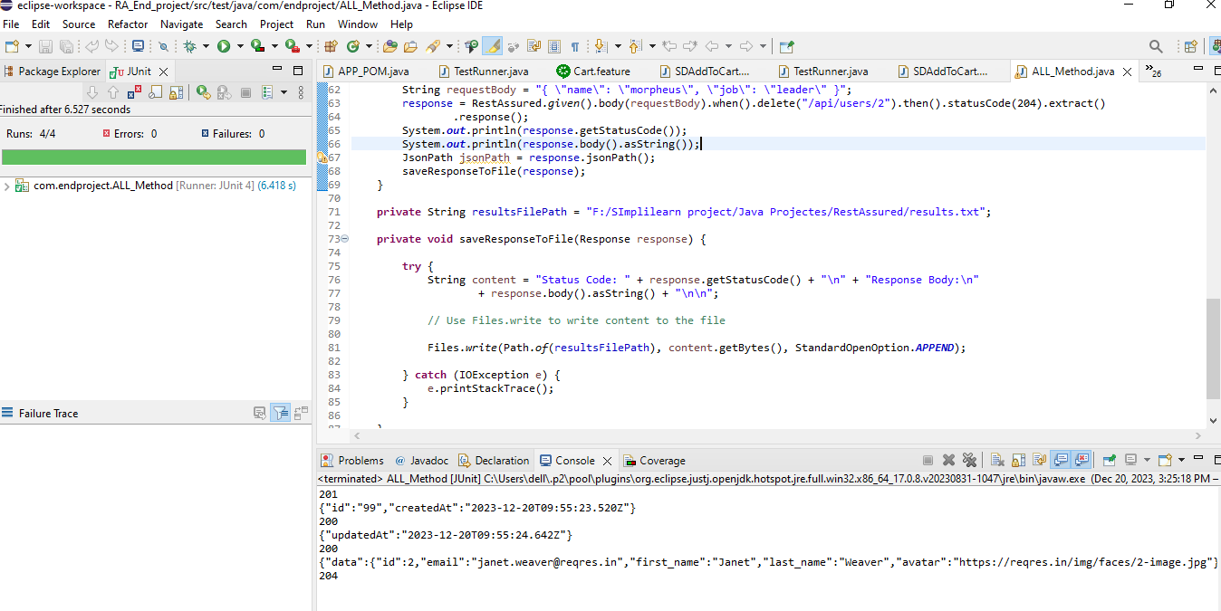

**Response:-** 201

{"id":"99","createdAt":"2023-12-20T09:55:23.520Z"}

200

{"updatedAt":"2023-12-20T09:55:24.642Z"}

200

{"data":{"id":2,"email":"janet.weaver@reqres.in","first_name":"Janet","last_name":"Weaver","avatar":"https://reqres.in/img/faces/2-image.jpg"},"support":{"url":"https://reqres.in/#support-heading","text":"To keep ReqRes free, contributions towards server costs are appreciated!"}}

204

**Results file:-**

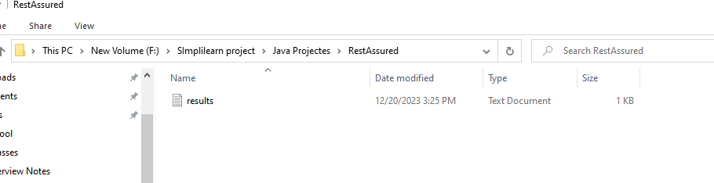

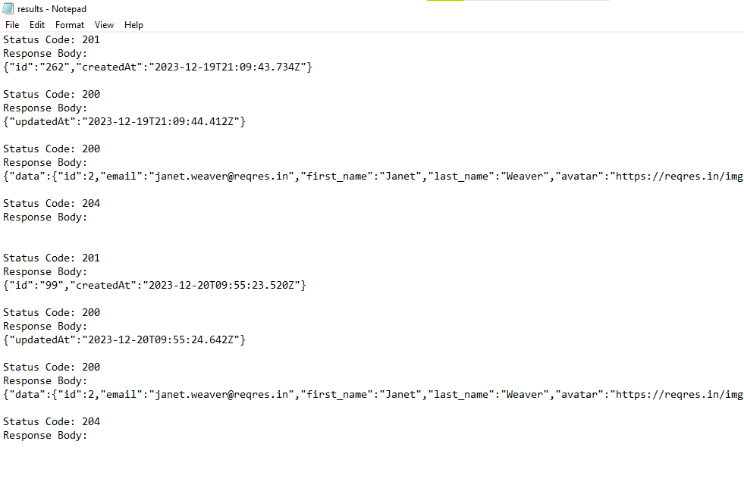

**Postman:-**

